**Category 6A Shielded Keystone Jack Ultra Slim**

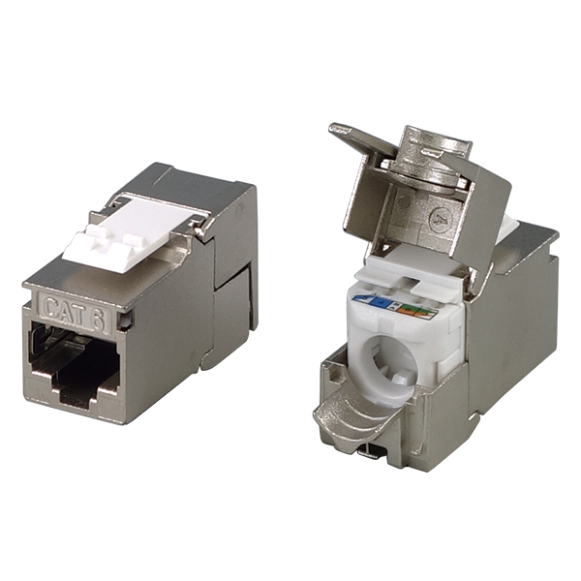

Category 6 shielded keystone jack is designed for superior performance and easy assembly, meets and exceeds ANSI/TIA-568.2-D and ISO/IEC 11801 2nd edition Category 6 standards, supporting Gigabit Ethernet application and beyond.  Ultra Slim design and half U design fits 0.5U 24-port, 1U 24-port & 1U 48-port empty panel for most efficient use of rack space.

## **Features**

Zinc-alloy metal shell

Half U (0.5U) system compatible

Tool-free

Contacts are phosphor bronze plated with 50 micro inches hard gold

Dual T568A &amp; T568B wiring

Polycarbonate 94V0 rated

Itertek ETL / Force EC Cat.6A VERIFIED

4PPoE compliant in accordance with IEEE802.bt Type 4

**Ordering Information**

|  |  |
| --- | --- |
| **Part No.** | **Description** |
| **1C68TPZ00** | RJ45, 8-Conductor Cat.6, Tool-free, Shielded, 180 degree, Ultra Slim, fits 0.5U panel |
| **1C68TPZ01** | RJ45, 8-Conductor Cat.6, Tool-free, Shielded, 180 degree, Ultra Slim, fits 0.5U panel, no cable tie required |
| **7C68TPZ00** | RJ45, 8-Conductor Cat.6, Tool-free, Shielded, 180 degree, Ultra Slim, fits 0.5U panel |